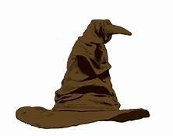
Wizards Workshop

With inspiration drawn from the Wizarding World of Harry Potter, East Granby Youth Services is providing program to “entertain and educate”. In this four week program we will teach young wizards how create spells to help them deal with difficult situations that cause them anxiety that every wizard needs to succeed.
Get ready to uncover what house you belong to, make your very own wands, discover our patrounese and create spell books that help us in every day life.
We hope your young wizard will enjoy practicing the magic spells they craft, while making new friends in a muggle-free zone.

When: Tuesday February 11 – March 10, 2020 (no class 2/18)
Where: Sears house
Cost: $15(financial assistance is available if needed)
Register online at http://eastgranbyrec.com/info/activities/default.aspx 