EGMS Games Club
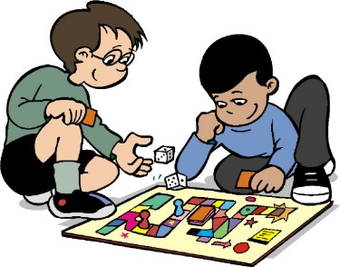

Do you like to play games? Computer games, board games, card based games, chess or role playing games. Then join the middle school games club. Please sign up in the office as soon as possible and let Mr.Berardy know if you’re interested in participating.

Where: EGMS Library– Permission forms available in the office

When: Tuesdays February 25 - March 31, 2020
Students will take the bus or be (Picked up promptly at 3:45pm in front of EGMS)

Who: East Granby Middle school students

Students may bring their own personal gaming systems, console gaming systems, board games, card games and other types of games with parental permission. No gaming software maybe installed on EGMS computers.

Questions?
Contact Mr.Berardy at pberardy@eastgranby.k12.ct.us

